**July 31, 2015, 9:00 - 9:45am.**

*Interview with Otis Wilder on the subject of using OASIS*

Below are a summary of points made in trying to ascertain how students use OASIS. One of the main lessons learned is that it is not easy for students to “browse” for classes without being admitted into a program of study. Most links set up for course searches are targeted only to students who are already in a program of study, and for those students who are not yet enrolled in a program of study and want to simply browse courses, the search mechanism delivers data that is hard to digest, in large tables with an overwhelming amount of data.

Link example one: Home page <http://www.usfsp.edu/home/>

On the left hand menu, under “Campus Connection” there is a link for Current Students but not for Prospective Students. See Figure One.

Link example two: <http://www.usfsp.edu/for-current-students/>

The label on the the link changes from: “For Students” to: “For Current Students”. This may cause confusion as there is not another, similar link that says something to the effect, “For Prospective Students”.

On the left hand side, under the “Academics” section, there is a link that says “Search for classes” This link takes one to the registrar’s page. <http://www.registrar.usf.edu/ssearch/search.php>

Link example three: <http://www.usfsp.edu/academics/> also has a section on the left menu, “Course Schedule Search”, that advertises itself as “A real-time search providing the most up-to-date information for course listings and availability. Search by term, session and campus for undergraduate and graduate course offerings.” and offers a link that leads to the same registrar’s page above. <http://www.registrar.usf.edu/ssearch/search.php>

This page “does” offer a comprehensive search, but an uninitiated prospective or new student will not understand how to use filters appropriately to select courses in a meaningful way pertinent to completing a degree. For example, by selecting “Distance Learning” classes, that without further selecting a campus, may not understand that he/she is choosing courses that may not apply to a degree.

This is actually also a problem for students who are already in a program of study. It does seem like the functionality of “Degree Works” would address many of these issues.

The bottom line is that for any students who simply want to “browse” classes before being admitted to USFSP, the path is not well-defined, and confusing.

Aside: We may be losing a marketing opportunity by not making the courses more easily found, and in a format that is more easily understood.

Aside: In addition to affecting potential students who simply want to browse classes, this will also affect the PID component of the portal, for students who do not yet have a NetID.

Otis found a link that provides an OASIS class schedule found for staff; we were both uncertain uncertain “why” there is a separate page for staff search--are there restricting criteria that apply to staff?

Otis also had a great recommendation (actually one of MANY great recommendations) that “if” one were to look at OASIS in a program of study, that the order in which one should take classes figure prominently. He recalled a study in which it was found that the order in which a student took courses affected the outcome (Otis will provide a link to the study at a future point).

As an example, we looked at the following page: <http://www.usfsp.edu/psychology/ba-in-psychology/>

On that page, there is a section called, “Recommendations for Maximizing Your Undergraduate Career” which offers recommendations for courses to take during the Freshman, Sophomore, Junior, Senior, and Year off. He felt it was a generally good idea, and on the right track. To strengthen the list in order to help students avoid some common pitfalls in their academic progress, he recommended that specific courses, in specific order, with notes about pre-requisites, be listed instead. See figure two.

Aside: He liked the expandable list, but also felt that if the user were able to leave the list item open at will, then that would help the user look at the requirements as a natural progression, instead of the traditional terms of Freshman, Sophomore, etc. This matters because non-traditional and some advanced-placement students would benefit from looking at a list in logical order of progression, rather than by year.

Finally, for students that have already been admitted to a degree program, the functionality of Degree Works may address many of the concerns by providing alerts and completion status. In our conversation, it came up repeatedly that once inside, the system doesn’t “warn” you against taking classes that don’t apply to a program of study.

We had to stop the conversation early due to the fact that Otis had other appointments, but we’ll pick it up again at the first opportunity.

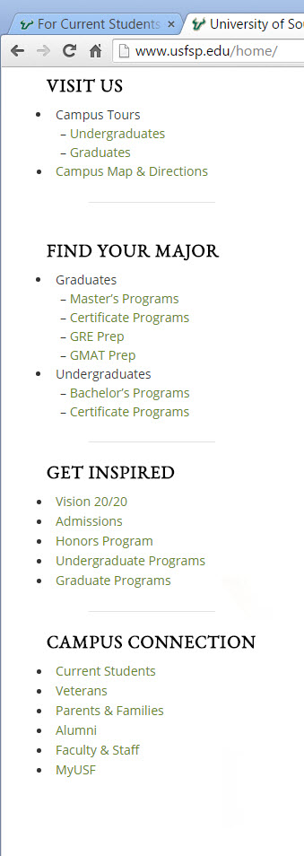

Figure One. How would prospective students find courses to explore?

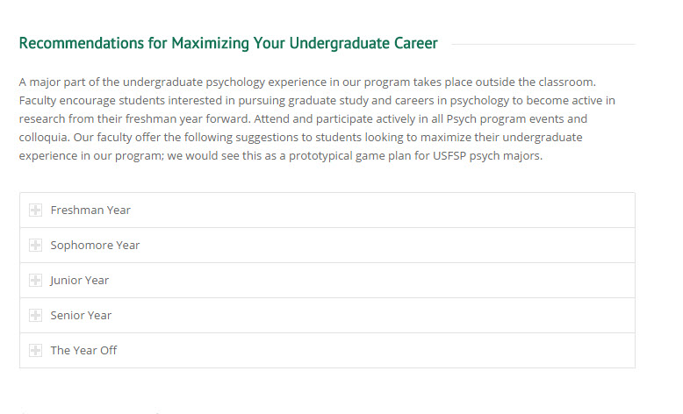

Figure Two. Is it possible to use this as a model for a logical progression of order of classes, in addition to, or instead of, a yearly basis?